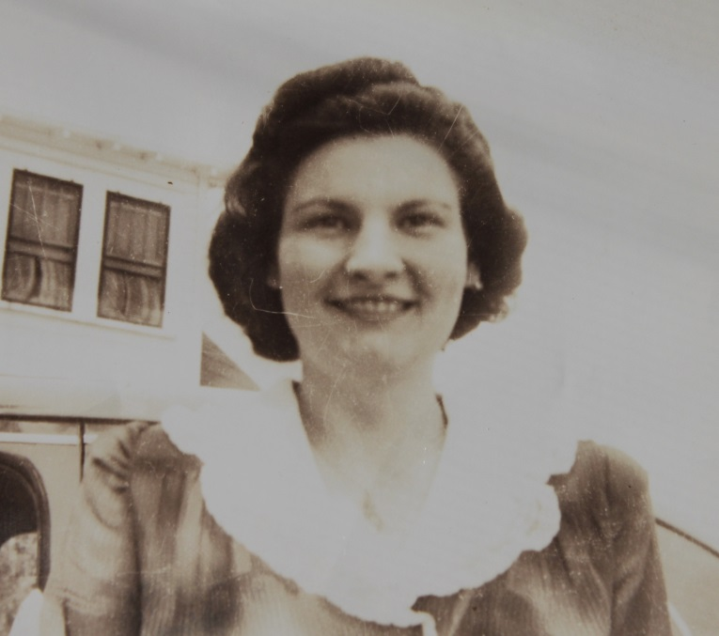

**Josephine Ann Wolfe Fischer - 1942**

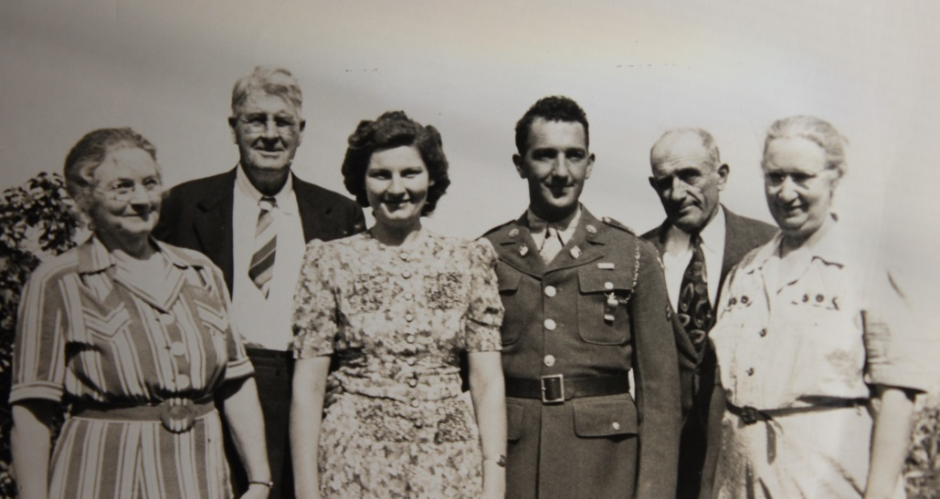

**(l-r) Josephine S. & Earl R. Wolfe; Josephine Ann & George J. Fischer;**

**George Andrew (Sr.) and Harriet Elizabeth McMahon Fischer (George’s parents) - 1942**